**Get Filename From File Path**

This document will explain how to use Run script.

Please go through the following sample automation **Get Filename in File Path. Zappy** file.

**Step 1:** Double Click on **“Get Filename in File Path. Zappy”** file.

**Step 2:** Run Zappy Task window will pop up. Click on OK.

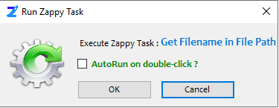

**Step 3:** Select the file.

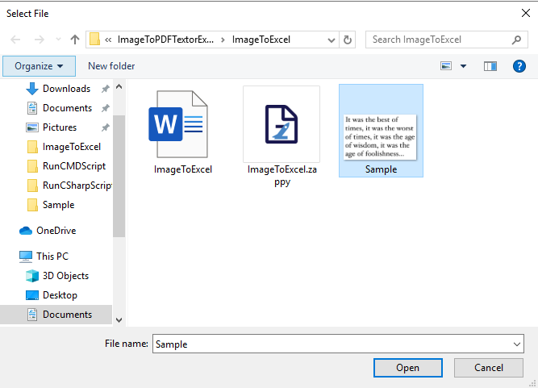

**Step 4:** Will see the onlyFile name is display on **Message Box,** then click on **OK** button.

